GRADE 1V
HOW MUSCLES CAUSE BODY MOVEMENT

At the end of the module, you will be able to:

- Explain and demonstrate how muscles cause body movement, cite simple
body activities that show the coordinated function of the skeletal and muscular systems.

Try to Recall


Activity 1

* Find the ten words hidden in the puzzle below.
* Tell whether a word pertains to the muscular or the skeletal system.

V
O
L
U
N
T
A
R
Y
M
U
S
C
L
E
S

O
W
C
B
Q
R
O
Y
W
I
M
P
L
E
Z
K
Y
O
T
F
W
E
R
T
Y
I
O
K
C
G
H
U
R
N
E
K
J
W
G
L
O
V
T
Y
U
B
V
L

A
C
N
R
A
E
L
G
H
I
J
J
K
O
H
L
T
S
D
S
C
R
M
S
H
B
F
E
B
N
E
F
N
G
O
J
R
T
Y
G
E
S
S
C
V
E
A
A
U
Y
N
K
O
Z
J
O
W
E
A
R
I
V
R
H

L
J
S
P
E
V
I
C
B
O
N
E
D
G
T
L
O
I
M
O
J
A
W
B
O
N
E
H
V
O
K
P
V
O
L
J
D
I
G
H
E
R
I
O
A
S
D
Y

N
X
B
R
E
A
S
T
B
O
N
E
A
X
H
R
I
U
Q
D
G
W
H
T
U
W
A
S
D
F
H
K

Activity 2

B

* Try to crack the following secret password. In each set of words below, a certain letter has been replaced by a shape. Figure out the letter that the shape stands for. Then, fill in the same shape in the password to decode the password.

1. h a 2. s t p 3. a s e 4. s t p
m

o o n m n k i y n t
m

a r s v a l l o e g g
m

5. k i f e 6. p a s e

e v e r o y

s e v e c e n avo

Explore

What was the password?
- You’ll learn in this lesson what helps you move.

Activity 3
Follow these steps to make the Muscle Maker Model

- For this activity you will need the Muscle Maker Model, a pair of scissors, and fastener, a cardboard and a paste.

1. Trace the diagram below to a sheet of bond paper then paste the sheet
of bond paper on a piece of hard cardboard.

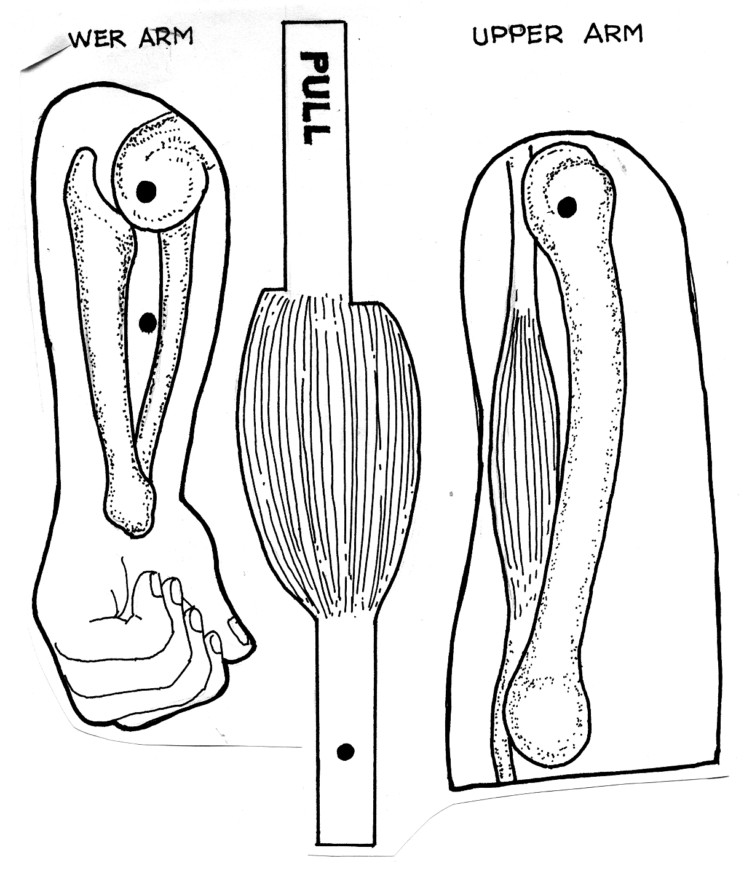
lower arm
Upper arm

2. Cut out the model along the solid black lines.
3. Cut open the slit along the black line of the upper arm piece.
4. Punch holes on the four black dots. Use the tip of the scissors or the fastener
to do this.
5. Set the two arm pieces at right angles to each other with the lower arm on top.
6. Put the fastener through the lower arm’s end hole, and the upper arm’s hole
as shown.

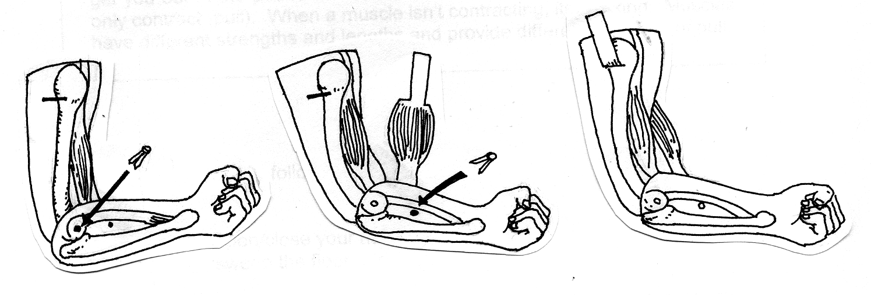

7. Put the muscle piece behind the arm pieces, aligning it hole with the other
hole on the lower arm then put the second fastener through.
8. Slide the end of the muscle labeled PULL through the slit.

You now have an armbone and muscle model now. Try using it.
Pulling the PULL tab. Describe what happens. How do you think this causes
movement?

Read and Learn More

Your body is made up of over 600 muscle groups and more than 200 bone muscles are attached to your bones by tough cords called tendons. These muscles and bones work together. Every moving bone has at least two muscles attached to it. One muscle contracts and pulls a bone to get you into a certain position, then its partner contracts to pull the bone back and get you out of the position. Muscles can only move in one direction. They only contract (pull). When a muscle is not contracting, it is relaxing. Muscles have different strengths and lengths and provide different amounts of pull.

Activity 2

Try to do the following actions
a. Sing
b. Jump
c. Open close your hands
d. Sweep the floor

Think about how your muscles and bones worked together in each action.

Read and learn more

When you are at work or at play, the parts of your body move in different ways. In all these movements, bones and muscles work in a coordinated way. When you eat or sing, your muscles in your face pull on certain bones to move your mouth. When you jump or walk, the muscles in your legs pull on certain bones so that you can move. When you sweep the floor, the muscles in your hand move certain bones so that you can hold the broom. The muscles in your upper arm move cedrtain bones so that you can do the sweeping motion.

In everything you do your bones and muscles work together.

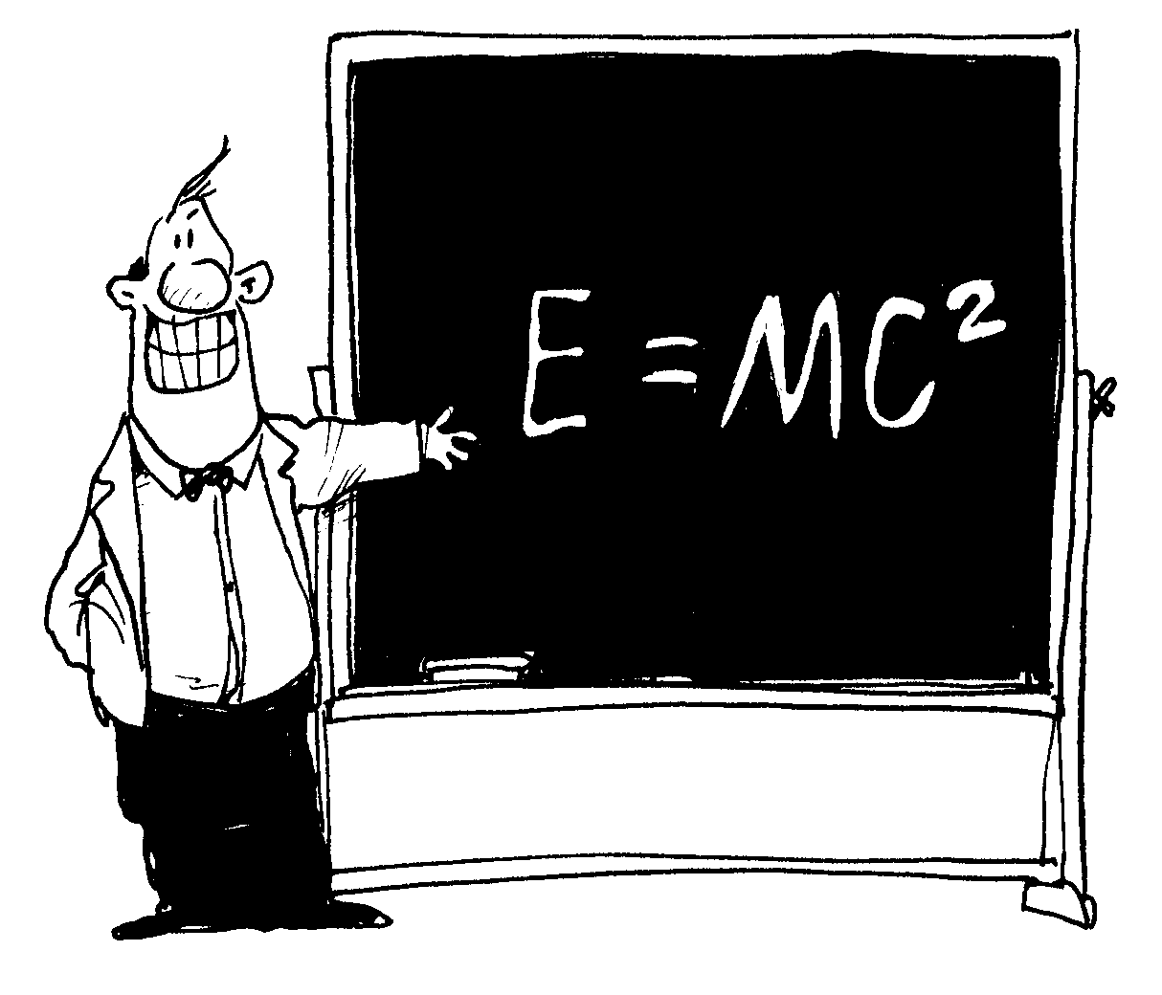
I learned that:

- Bones cannot move by themselves.
- Muscles move the bones.
- Many activities can be done with the skeletal and muscular system working together.

Apply It
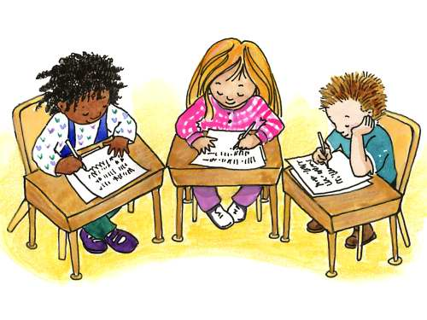

1. Explain how your muscles and bones work together when you eat, hold a
book and walk.
2. Explain what would happen if your body was made up of either only all
bones or all muscles.
3. Explain would happen if the tendons that hold the muscles to your bones are
cut.

Test Yourself
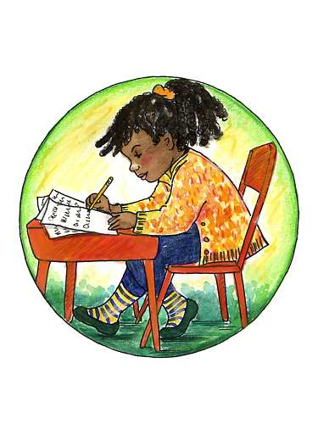

A. Write the letter of the correct answer in your notebook.

_____ 1. How do muscles work?

a. in threes c. in solo
b. in pairs d. in fours

_____ 2. How do muscles move?

a. by extraction c. by absorption
b. by contraction d. by relaxation

_____ 3. When one muscle is contracting, what is its partner doing?

a. bending c. relaxing
b. stretching d. pulling

_____ 4. In how many directions can muscles move?

a. one c. three
b. two d. four

_____ 5. How does walking show the coordinated work of the skeletal and muscular system?

- The bones pull the muscles to move.
- The muscles and bones pull against each other.
- The muscles push the bones.
- The muscles pull the bones to move.

B. 1. List three activities that show the coordination of the bones and
muscles. Explain.

