GRADE VI
STUDYING THE UNIVERSE

At the end of the module, you should be able to:

- Identify modern space facilities, tools and equipment used to study the universe
- Explain the theories about the universe



Try to Recall

- Draw the three types of galaxies. Do it on your notebook.

B. Read the word inside the circle. Write all the words/ideas that comes into your mind upon reading it.
UNIVERSE

Explore

Activity 1

How can you study the universe? What instruments do you need? Draw them in the space provided below.

Read and learn more.

The basic instruments that we use to study the universe are our eyes, intelligence, and imagination, to keep our sense organs, different pieces of equipment have been invinlied and some procedures have been developed. These are:

- Telescope – in astronomy any instrument for collecting radiation from any part of the universe is a telescope
- Spectroscope – is used to study the chemical compositions of the stars.
- Photograph – is used to measures the brighten of the stars from the size and clearness of images
- Radio Telescope – detect heavenly objects and celestial events that optical devices like telescope cannot reveal.
- Space Telescope – flown to the space orbiting high above the atmosphere to observe the ultraviolet rays of the sun.

Activity 2

Differentiate optical telescope from spectroscope

Telescope Spectroscope

__________ __________
__________ __________
__________ __________
__________ __________

Radio telescope Space Telescope

__________ __________
__________ __________
__________ __________
__________ __________

I LEARNED THAT:

- The instruments used to study the universe are the telescope, spectroscope, camera, radio telescope, and space telescope

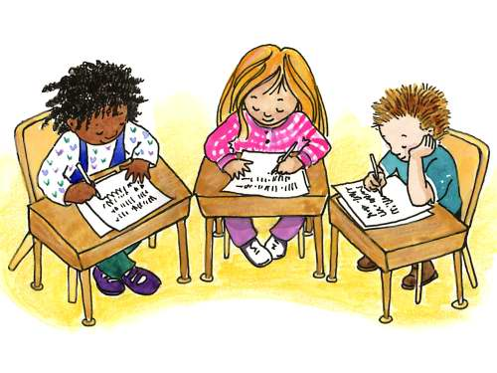

Apply It

If you were asked to study the universe using the different equipments you learned, list as many objects that you think are found in the outer space. Draw your answer in the box below.



Test Yourself

*

Enumerate basic instruments you will use to study the universe. Discuss each.

1. __________ ____________________

2. __________ ____________________

3. __________ ____________________

4. __________ ____________________

5. __________ ____________________

Key to Correction

Try t o Recall

Exploration Time

Activity 1
Answer these

Activity 2
Answer these

Activity 3
Answer these

Apply it

A

B

C.

D.

Test Yourself

- Satellite
- Space Station
- Space Probe
- Space Shuttle
5. Space camera

