GRADE V
PROPERTIES OF ROCKS

At the end of the module, you should be able to:

- Compare rocks according to their properties such as color, shape, size, hardness, texture, etc
- Classify rocks according to properties



Try to Recall

Study each picture below.
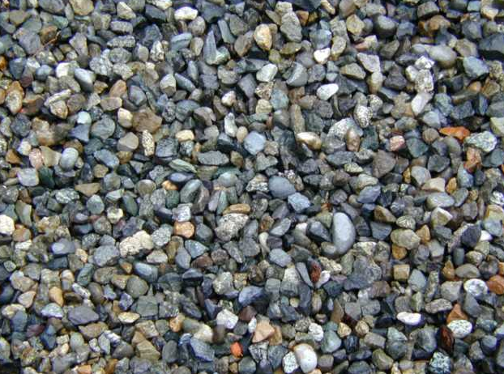  pebbles | 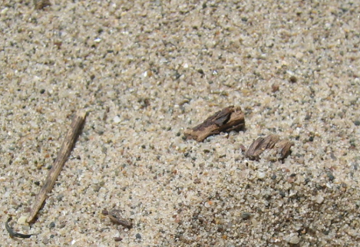  sand
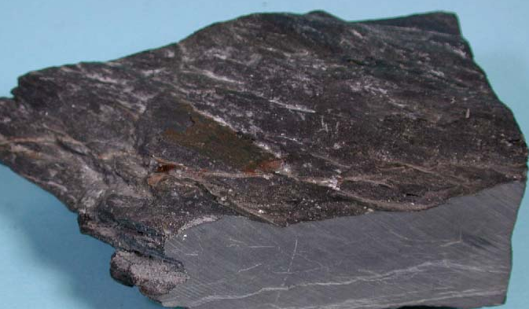  limestone | 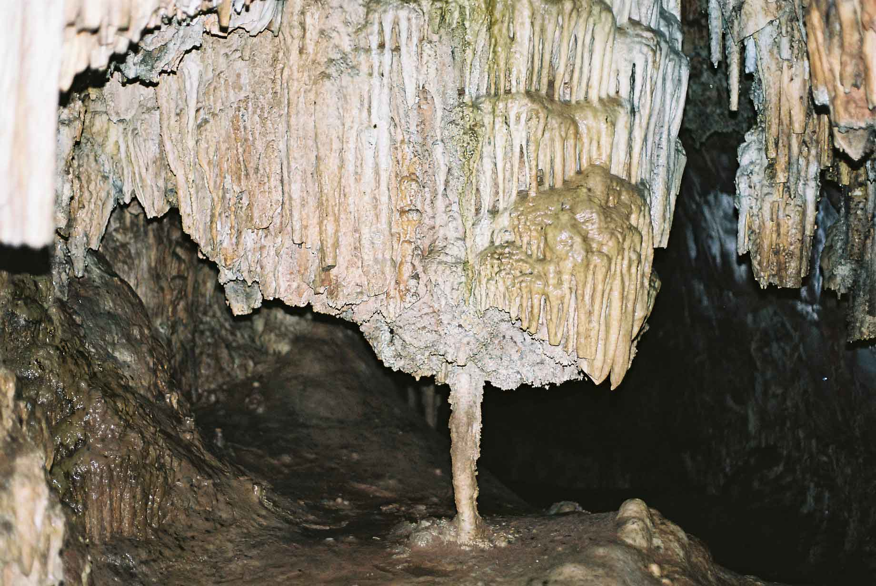  stalactite

What are shown in the pictures?

Explore

Activity 1

A.

In this activity, you will find out how rocks differ from one another.

- Collect five different rock samples found near your home or school. Make a note about where you found each sample.

- Number each sample. Study each samples. Note the following:

- size – whether small (as big as 10-centavo coin),
medium (as big as 25-centavo coin)
large (as big or bigger than a 1-peso coin)

- shape – whether round, oblong, squarish, or other shape.

- color – any color

- weight – whether light,
heavy,
very heavy

- hardness – whether soft,
not so hard,
hard, or
very hard

- texture – whether smooth or rough

3. Copy the table below in your notebook. Then fill it with your observation on your rock sample.

Rock samples | D E S C R I P T I O N S
Rock samples | Size | Shape | Color | Weight | Texture | Hardness

4. Analyze the characteristics of the rock samples. Then answer the following questions.
Write the answers in your notebook.

- Which sample is the heaviest?

- Which sample is the hardest? Why do you think so?

- Which samples are smooth? rough?

- What colors did the samples have?

- Does the size of a rock sample affect its weight?

- In what ways do rocks differ?

Activity 2

- Observe the samples used the previous activity.
- Study the table generously prepared in activity 1. Take note of the observable characteristics among the sample.
- Group the rock samples according to the following criteria
- color
- shape
- texture
- hardness
- Prepare a table per category.
- Answer the following questions.
- How many samples are there per observed color?
(reddish, white, gray, yellowish)
- How many samples are there in each shape?
- How many samples are rough? smooth?
- How many of the samples are soft? Not so hard? Hard? Very hard?

Read and learn more.

Rocks are found in places such as riverbanks, excavations, beaches, quarries, and dumpsites. Some rocks are found above the ground, others below the surface, deep down in the earth and still others at the bottom of the sea. Rocks may seem to be the most ordinary thing in the world until you really look at it. When you do this, then it becomes a uniquely interesting object. rocks can be identified by their physical characteristics such as color, shape, size, weight, hardness and texture. These characteristics make rocks different from one another. Rocks also differ from one another due to their mineral composition. Rocks can be identified by the color of minerals in them.

I HAVE LEARNED THAT:

- Rocks have differ in shape, size, weight, color, hardness, and texture
- The observable physical characteristic can be used to classify them.



Apply It

- How will you differentiate the two rocks below? Write the answers in your notebook.

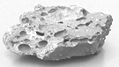 | 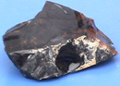

- Mang Antonio will start to build his own concrete house. He wants to ensure
the durability of the posts he will be using for his house. What characteristics of
rocks should he consider when he buys the materials?



Test Yourself

*

- Copy the puzzle below in your notebook then complete it with the different characteristics of rocks.

1
S

2
T
3
H

4
W

5
C

DOWN

1. This gives form to an object.
- This is the roughness or the smoothness of an object.

ACROSS

- This could be determined using mohs scale.
- This tells whether an object is heavy or light.
- This is the quality of reflected light. That makes an object more attractive.

- Identify the property of a rock that is being referred to in each statement below. Write the answer in your notebook.

1. The rock is dark blue.
2. I like this rock. It is smooth. It has fine grains.
3. This rocks oval shape can add beauty to my rock garden.
4. Diamonds can scratch glass and mirrors.
5. This rock is very light.

