GRADE VI
VULCAN: THE BLACKSMITH OF GOD JUPITER

At the end of the module, you should be able to:

- Describes how volcanic eruption occurs



Try to Recall

Do this in your notebook.
Match column A with column B. Writes only the letters.

A B
______ 1. valley | a.
______ 2. hill | b.
______ 3. mountain | c.
______ 4. plateau | d.
______ 5. volcano | e.
 | f.

Explore

Do the activities. All your answers must be written in your notebook.

Activity 1

Study the illustration below and answer the questions that follow:

- What are the parts of a volcano?
- What materials do you think that are found inside a volcano?
- Where does magma pass?
- Why do you think it emits smoke?

Activity 2

Read the story below.
Formation of Mt. Paricutin n Mexico

February 20, 1943 began like any other day for Dionisio Pulido. Señor Pulido and the other farmers of the tiny Paricutin village in Western Mexico were clearing their land. Before nightfall they would experience an adventure they would not soon forget.

Señor Pulido noticed a small opening in the ground. Cracks are not uncommon in this part of Mexico, but this one was different. Dionisio cautiously peeped into this rather shallow fissure. He was greeted by a puff of smoke which smelled strongly of sulfur! The ground began to sway, and the grinding rocks rumbled like thunder. More smoke boiled out of the ground, only now it was accompanied by glowings sparks which showered the area. Soon the grass was afire.

A short while later, stones and ashes were being thrown from the smoking vent in Señor Pulido’s cornfield. The rocks began to form a cone-shaped hill around the opening. Within a week it had reached a height of 450 feet. Tons of rocks and smoke continued to roar skyward! After 60 days, the cone loomed more than 1,000 feet above Dionisio’s now buried cornfield! It is still there today.

Sequence the formation of volcano as happened in the story.

- Sulfur smelling smoke puffed out of the shallow fissure
- Cone-shaped hill form around the opening
- A small opening was natured in Señor Pullido confield
- Smoke with glowing sparks came out of the opening
- Come loomed more than 1,000 feet above the confield
- Stones, and ashes were thrown out from the smoking vent

Activity 3

- Prepare the following materials

- two small plastic drink bottles
- large piece of card board
- vinegar
- bicarbonate of soda
- tablespoon
- teaspoon
- orange food coloring
- liquid soap
- large plate or tray
- funnel (embudo)
- scissors
- tape

- Copy the shape onto two pieces of cardboard. It needs to be big enough to fit around the bottle.

- Cut and bend it into a cone. Secure it with a tape.
Using a funnel, pour vinegar until it is about one-third full of vinegar.
- Label this bottle A.
- Add a few drops of food coloring.
- Add 1 tablespoon of liquid soap.
- In another bottle (B) put 1 tablespoonful of bicarbonate of soda and a few drops of orange food color.
- Place the cone-shape card onto the bottle of soda.
- Using a funnel, pour in the vinegar and liquid soap mixture.
- Remove the funnel.
- Wait and observe.

Answer these:

- Describe what happens in the two bottles.
- Why do you think the vinegar in bottle B overflowed and it did not in bottle A?
- Compare this activity to a real volcanic eruptions.
4. Infer how volcanic eruptions occur?

Read and learn more.

Volcanoes are mountain with vents and fissure that connect a reservoir of magma (molten rock) to the surface. Molten rock, usually called magma while it is beneath the earth’s surface and lava when it is finds it’s way to the surface through fissure or cylindrical openings.

Volcanoes are not all alike. Because of the difference in magma composition volcanoes differ in appearance and in manner of eruption.

The lava cone volcano is characterized by wide base. The materials popping out of the volcano cone are made up mostly of lava which flows rapidly down the slope, solidifying and forming very wide base. This is also called shield cone volcano.

The cinder cone volcano is usually form from ashes and other dust materials that are thrown up so high that they harden before they can spread farther down the slope. This hardening results is a steep cone with narrow base.

The composite cone volcano is halfway in steepness between a lava cone and a cinder cone. This caused as the lava within the volcano vary as the lava within the volcano changes.

What comes out of a Volcano
The smoke that comes out of the crater in a volcanic eruption is actually a mixture of gases. It is made up of mostly water vapor and gases including carbon monoxide, carbon dioxide, sulfur dioxide, methane, and ammonium chloride

Solid particles like rocks, ashes, and dust particles are thrown out during a volcanic eruption. They pile up along the slow of the volcano. When there is heavy rain, these materials are carried in stream of mudflow commonly called lahar.

Formation of Volcanoes

One of the results of the movement of the crustal plates is the formation of volcanoes. How does this come about?

As mentioned, the movement of two plates may cause one plate to be pushed beneath the other plate. If a plate carrying a continent collides with another plate which is part of the land under the sea, the plate under the sea is pushed beneath the continent. This makes the oceanic plate bend. The bending of the plate creates pressure that acts on the inner rocks. As pressure increases, more heat is produced resulting in the melting of rocks. Molten rock is called magma.

A volcano is an opening in the earth’s crust. Hot gases, liquid and solid materials reach the surface of the earth through this opening often quietly but sometimes violently. The largest number of volcanoes can be found under the sea where the crust is thin. Magma is able to pierce through the weak parts of the crust. Some volcanoes may form along the plate boundaries. But there are other volcanoes that are found farther away from plate boundaries. Scientists believe that this happens because magma finds its way up at other places from the interior of the earth.

Basic Facts About Volcano

What is volcano?
A volcano is a mountain formed from solidified lava from different eruptions. Lava that flows out can come from 30 to 60 kilometers, deep inside the Earth.

Where are volcanoes found?
Volcanoes are usually found near the boundaries of continental plates, which form the Earth’s outer layer.

How volcano is formed?
A volcano is formed by pressure building up below the Earth’s crust. Magma forces it way through weaknesses in the earth’s crust. When the magma emerges it is called lava. When it cools, it solidifies into rock, or it may emerge through thin cracks, which are called fissure. Or it may be forced through wider pipes, that starts to build up, to a volcano.

What are the shapes of volcanoes?
The shapes of a volcano depend on what type of lava. Viscous lava, is thick and sticky, that cools quickly, which can solidify building up steep sided cones. Non viscous lava, is thin and runny, that can flow for several kilometers before it cools.

These are some shapes of volcanoes.
- Shield volcanoes are shaped like upturned saucers, with gentle slopes.
- Cinder cone volcanoes are high, with steep slopes.
- Strato volcanoes are cone-shaped mountains.

I LEARNED THAT:

- The tremendous amount of heat and pressure from inside cause the expulsion of magma out.
- The material thrown out of a volcano are accumulate at the base of the volcano.



Apply It

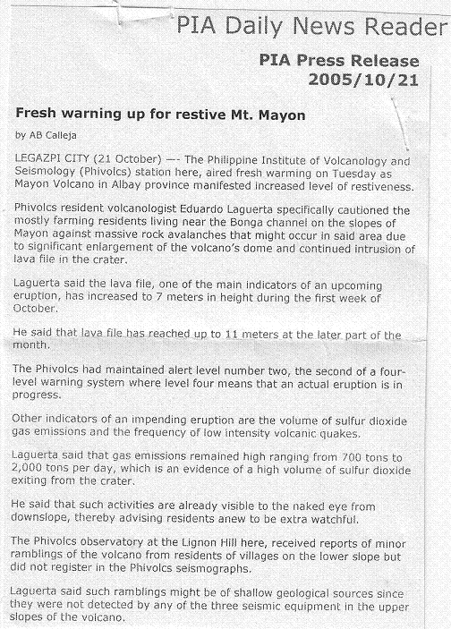

If you were living in areas mentioned. What would you do?



Test Yourself

*

Sequence the following situation on how a volcano is formed until its eruptions. Write numbers 1-5 before each statement.

____ A. Presents a mounting structure that forms around the cones. The accumulating molten rocks may rise to hundred of metres above the ground. When this happens a volcano is born.

____ B. Hot molten rocks flow out of the vent. This phenomenon is usually accompanied by ground trembling. The moving molten rocks, called magma reach the earth’s surface and flow out as lava. The lava cools, become solid and accumulates in the surrounding area. A low-elevated land form called cone develops.

____ C. A crack beneath the Earth’s crust extends to the surface and widens. A billowing cloud of smoke escaped out of the small hole called vent.

____ D. Due to the pressure generated inside the Earth, the magma come out of the volcano either quietly or violently.

B. Following the stages on how a volcano is formed above. Illustrate how it is formed.

Key to Correction

Try to Recall

Exploration Time

Activity 1

Activity 2

Activity 3

Answer these:

Apply it

Test Yourself

3 - A
2 - B
1 - C
4 - D

