GRADE V
SEPERATING SUBSTANCE IN MIXTURES

At the end of the module, you should be able to

- demonstrate how certain mixtures can be separated.

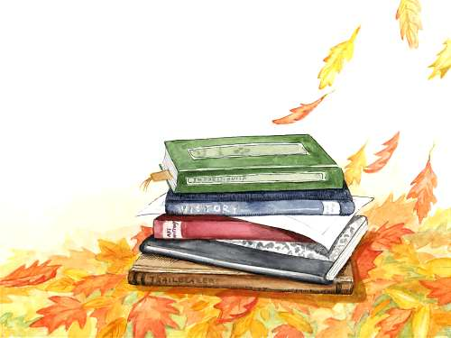

Try to Recall

Answer this question:

What factors affect the dissolving rate of solutes?

Explore

Activity 1

Do the following activities and answer the questions in your notebook.

A. 1. Combine a spoonful each of uncooked corn, palay and mongo seeds.

2. Put these substances together in a dish and mix them with your fingers.

3. Pick up the corn seeds and place them on a piece of paper.

4. Do the same with palay and mongo seeds. Put each king of seed on separate pieces of paper.

- What is the mixture made of?
- How did you separate the mixture into the different substances, it is made off?

B. 1. Get a glass of water and a scoop of sand.

2. Mix the water and the sand. Pass the mixture through a cheesecloth.

3. Observe what happens.

4. Record your observation in your notebook.

a. How did you separate the sand from the water?

1. Get some iron filings.

2. Mix them with flour.

3. Hold a magnet over the mixture.

4. Observe and record what happens.

- What happened?
- Why do you think this happened?

D. 1. Get a candle, evaporating dish or foil formed into a box, old feeding bottle tongs, softdrinks.

2. Pour 10 ml of the softdrink into the evaporating dish or foil.

3. Gently heat it until most of the water has evaporated. (Be careful not to burn it.)

4. Allow the dish to cool. Examine the substance remaining in the dish. Describe the product left in the foil/dish. Where did the water go? What made the water disappear?

- What do you think is left in the evaporating disk/foil?
- Where did the water go?
- What made the water disappear?

Read and Learn More.

The method of separating the substance that make up mixture depend on the physical properties of the substances. Mixture made up of large particles like rice and tiny stone maybe handpicked.

In a mixture of grains, sand, and water, the grains of sand cannot pass through the cheesecloth. Water separates from the water when it passes through the cheesecloth. This method of separating mixtures is called filtration. In filtration, solutions or gases pass through the filter but particles which cannot fit through the filter are trapped by it. An example for this is to filter a mixture of pepper and water. In the laboratory, filtration is carried out using filter paper but we also use filtration at home like when we use tea strainers, face mask and food strainer. In common language when we use the sieve (salaan), we are sieving. An example of this is when we separate coconut milk from the grated coconut meat.

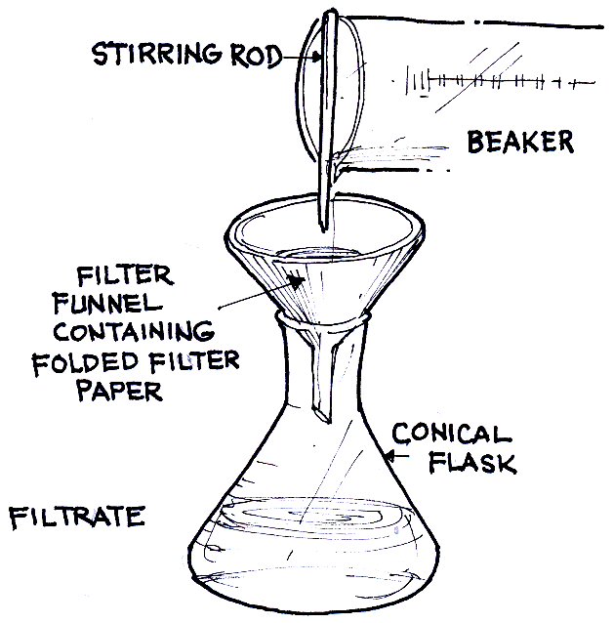
stirring rod

beaker

filter funnel containing folded filter paper

Conical flask

filtrate

We can use a filter to separate finer grains/particles from coarser ones. The process is known as sifting.

Magnet maybe used to separate mixtures when one of its components is magnetic like iron filings and small nails. The magnetic material is attracted by the magnet, leaving the non-magnetic material behind substances that are not soluble that are mixed with solutes maybe separated by sieving or filteration. This means that the mixture can be a made to pass through a cheesecloth/sieve or filler paper.

A mixture of solute and solvent may be allowed to stand to let the undissolved substance to settle at the bottom of the container. Then the liquid may poured slowly to leave the solid particles. This is known as decantation.

Another way of separating mixtures is by evaporation. Applying heat will cause the liquid in a mixture to evaporate leaving the other component/substance behind.

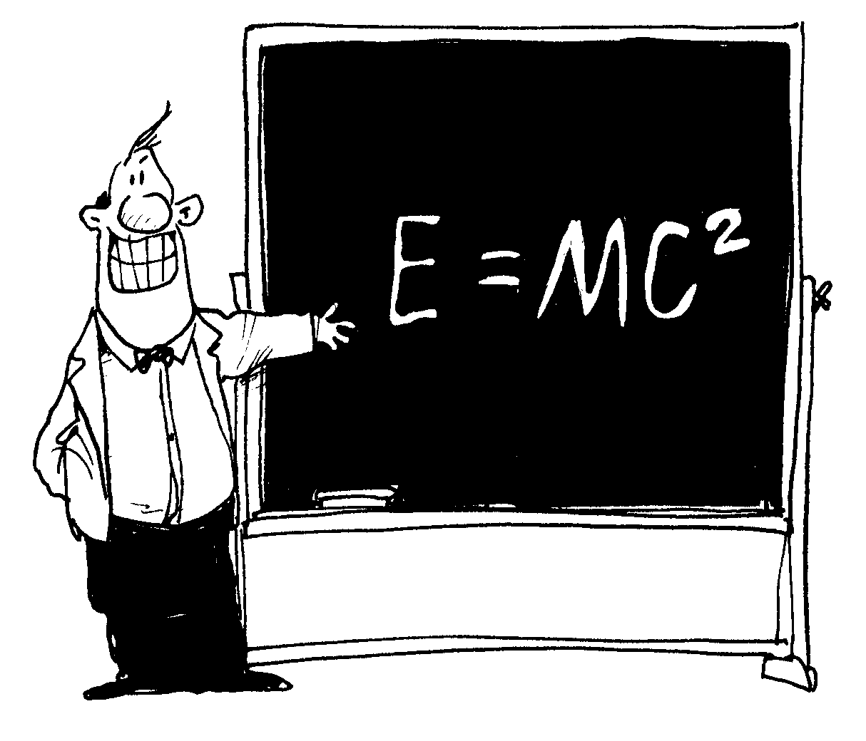
I have learned that:

- mixtures can be separated by:

  - picking up each solid;
  - sieving to separate liquid from solid;
  - using cheesecloth with filter paper
  - using a magnet to separate iron filings or magnetic materials;
  - decantation wherein the sediment is allowed to settle at the bottom of the container and then the liquid is carefully poured off; and
  - filtration wherein solutions or gases pass through a filter.



Apply It

1. If every tiny nuts were accidentally dropped on a pale of sand, how could you quickly separate the nails from the sands?

2. Mix cold water and flour in a jar. Stir very well. After a few minutes, you can see sediments at the bottom of the jar. How could you separate the sediments from the water?

3. The members of your family ate different kinds of fruits. When they were done eating, you gathered the seeds from some of the fruits and put these in a basin. Later, your father asked you to separate the seeds according to kind. How will you separate each kind of seed?

4. Mix sand and water in a basin. If you were asked try to separate the sand from the water, what will you do?

5. Dissolve one teaspoon of sugar in a cup of water. If you were asked to separate the sugar from the water, what will you do?
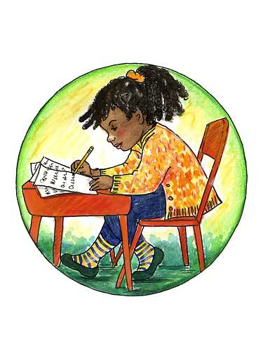

Test Yourself

- Name at least three ways of separating mixture. Differentiate them from below.
Write the answer in your notebook.

B. Identify the method you can use to separate the substance in each mixture below.
Write the answer in your notebook.

- scrap iron and plastic
- avocado, mango, and chico seeds
- lime and water
- sand and gravel
- pebbles and water
- salt and water

C. Answer each problem.

- You made a cup of coffee. Unfortunately you mistook the salt in your kitchen for sugar and accidentally mixed with your coffee. Can you still separate the salt from your drink? Why?

2. Your sister happened to mix iodized salt with white sugar. Can she still separate the two substances? Why?

