GRADE VI
CHEMICAL ENERGY

At the end of the module, you should be able to:

- Identify energy and its uses (chemical)



Try to Recall

Tell whether the energy used in each activity is mechanical potential or kinetic.

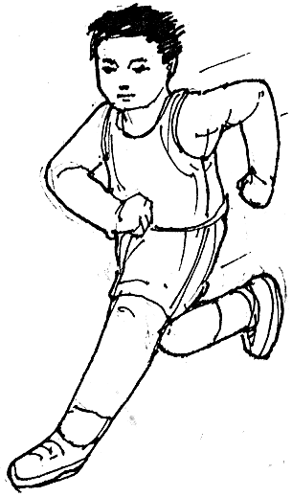
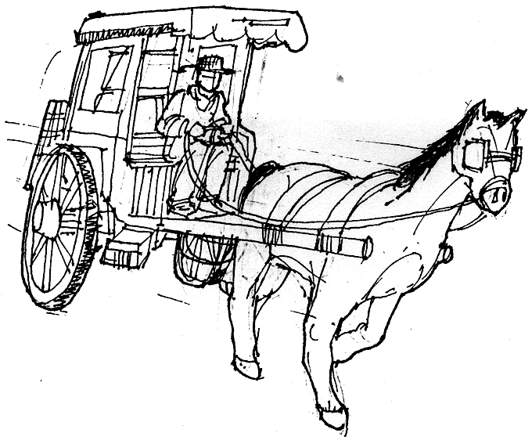

_____________________ _____________________

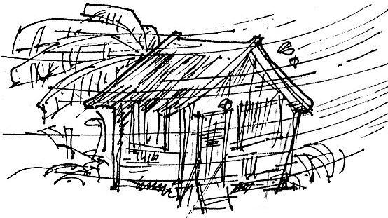
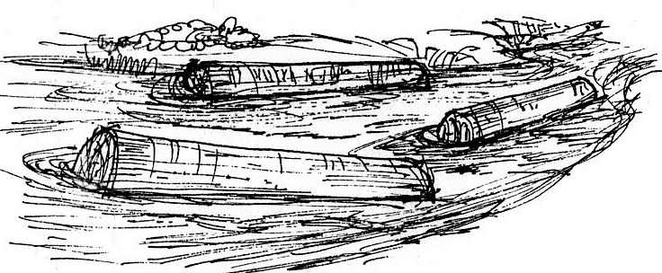

_____________________ _____________________

Explore

In the following activity, you will learn sources of chemical energy.

Activity 1

What you need:

piece of paper
match

What to do:

- Burn completely a piece of paper.
- Describe the changes that happened:

Paper Before Burning | Paper After Burning
1. | 1.
2. | 2.

- What new substances were formed after burning?
- Was heat formed while burning?

Did you know that…

during chemical change, energy is produced. This energy is known as chemical energy. It is observed as heat and light.

- Trace the energy changes while burning.

chemical energy
burning heat and light energy

Activity 2

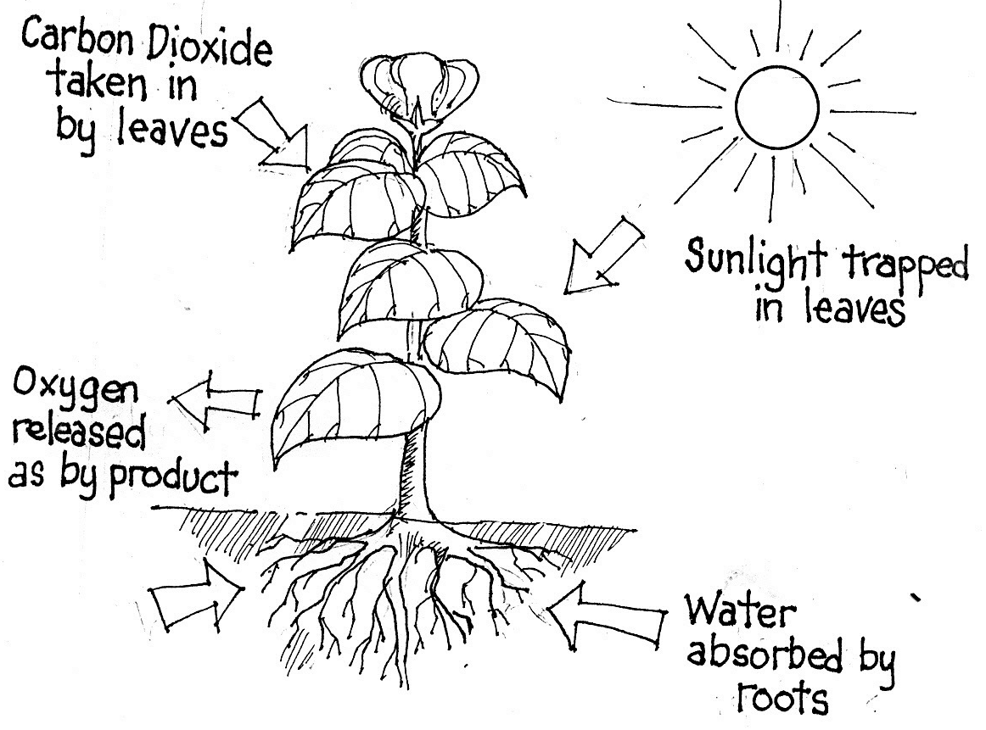

What to do:

- Study the process of photosynthesis in plants.

During photosynthesis

Water +
carbon dioxide + light chemical reaction glucose
(sugar)

- What materials are needed to make food in the leaves of plants?
- What happens when these materials undergo chemical reaction in the leaves?
- During chemical reaction or chemical change, what energy is produced?
- Describe chemical energy in this activity.
- What are some uses of chemical energy?
- Trace the energy changes

____________energy __________energy
light of sun glucose (sugar)

Activity 3

What you need:

a battery
a wire or a flashlight
a flashlight bulb

What to do:

- Switch on the flashlight without battery.
  - Did it produce light? Why?

2. Put battery in the flashlight.
  - Switch on the flashlight.
  - Did the flashlight produce light? Why?
  - What is the source of energy?
  - Can you tell what happened in the bulb when wire is connected to it after putting batteries?

Did you know that…

the substances inside the battery chemically react to produce a new substance.

3. Name other gadgets/appliances that use batteries.
Trace how chemical energy in each is transformed.

4. Trace the energy transformation:

chemical energy ____________energy
stored substances light of flashlilght
in battery

Read and Learn More.

Food, batteries, and fuels store energy. This stored energy is known as chemical energy. Food stores chemical energy. The food that we eat provides us with energy to do work and keep our bodies warm. Batteries also store chemical energy. When we switch on a battery operated equipment, the chemical energy inside the batteries is changed to electrical energy. This enables the equipment to work. When fuels are burnt, they give off heat and light energy. Some examples of fuels are oil, coal, gas, wood, and charcoal. All fuels store chemical energy.

I LEARNED THAT:

- Chemical energy is stored in substances. It is released when chemical reaction takes place.

- Food, batteries and fuels store energy called chemical energy.

- Chemical energy can be transformed to another form.

- When battery-operated equipment are turned on, the chemical energy inside the batteries is changed to electrical energy.

- The chemical energy stored in fuels are converted to other forms of energy during burning.

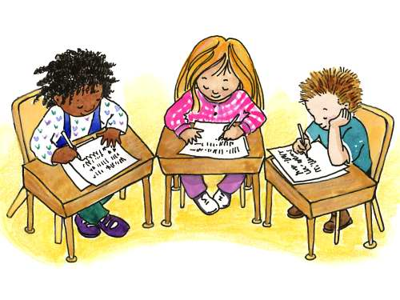

Apply It

Your younger brother likes to eat only fried chicken. He lacks other food nutrients that makes him weak and easily get tired. What will you tell him to become healthy and always on the go?

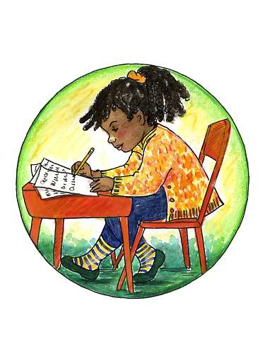

Test Yourself

*

The following restore chemical energy tell what each provide us once chemical energy is released.

- Food
- Batteries
- Fuels

Key to Correction

Try to Recall

Exploration Time

Activity 1

Activity 2

Activity 3

Apply it

Test Yourself

in any order

digestion
gasoline
coal
photosynthesis
burning
medicine

