TYPES OF BLOOD CIRCULATION
GRADE VI
TYPES OF BLOOD CIRCULATION

At the end of the module, you should be able to:

- trace the path of blood as it flows from the heart to the different parts
of the body



Try to Recall
Directions: answer this on your notebook.

1. Identify the parts of a cross-section of the heart as indicated by the numbers.
Choose from the following:
aorta right auricle right ventricle
vein left auricle left ventricle
pulmonary artery vein pulmonary vein

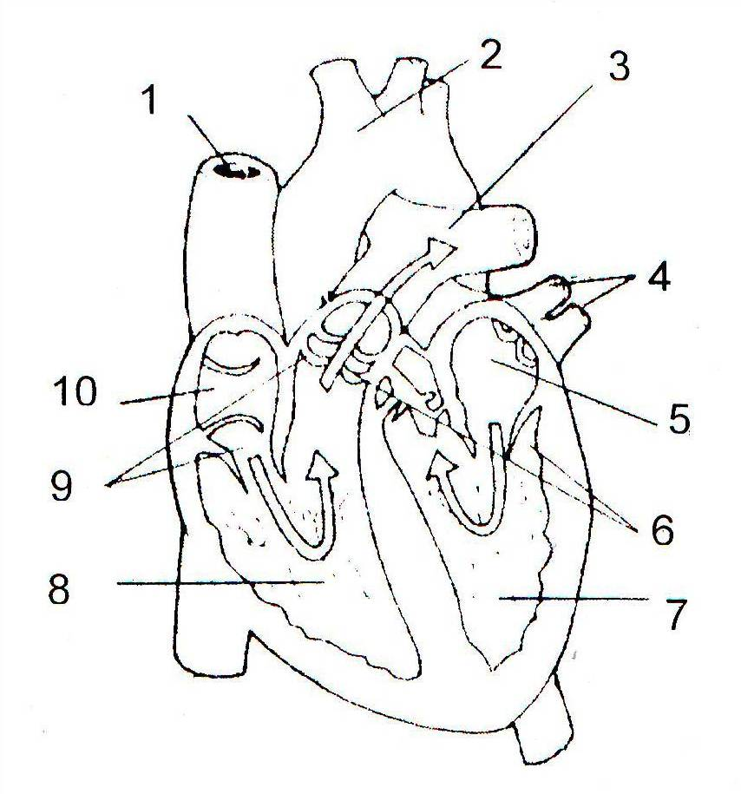

Explore

Activity 1

- Study the illustration. Trace with your finger the flow of blood in the diagram.
  - From the right atrium, blood with carbon dioxide moves down to the right ventricle, passes through the pulmonary artery, to the right and left lung.
  - From the right and left lung, it passes through the pulmonary vein to the left atrium.
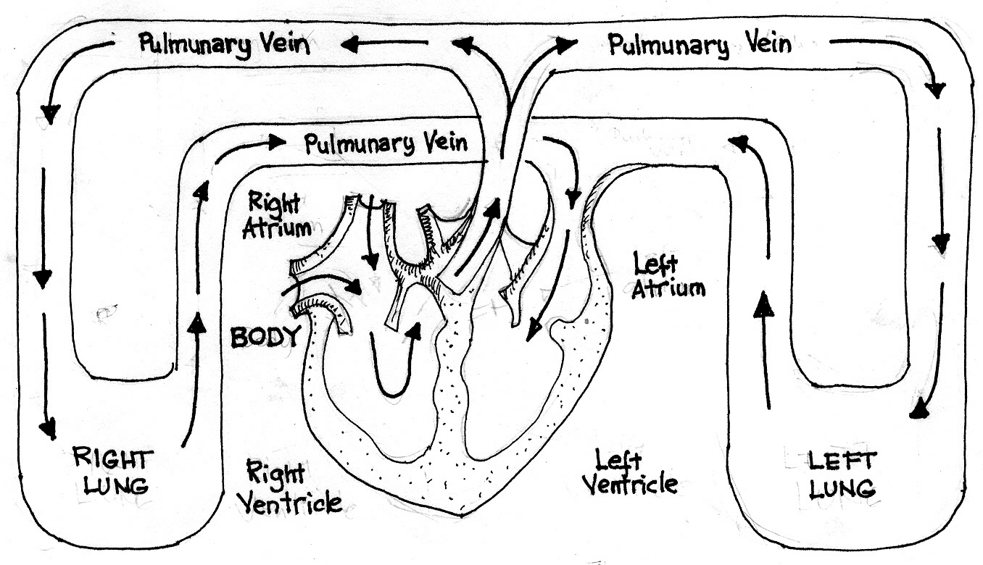
Pulmonary Vein
Pulmonary Vein
vein

Pulmonary Vein

The pulmonary circuit

- Trace the path of blood as shown by the arrows.
Write the correct words in each blank below to trace the path of blood in pulmonary circuit.

Blood from the right atrium, 1. _____ ventricle pulmonary artery right and left 2._______ 3._____vein 4.______ atrium

You have just learned about the pulmonary circuit. In pulmonary circuit the blood moves from the heart to the lungs and back to the heart.

In the next activity you will discover another route the blood takes as it is being pumped by the heart. This path of blood flow is called the systemic circuit.

Activity 2

1. Study the illustration. Trace with your finger the flow of blood in the diagram.
- From the left atrium, blood moves down to the left ventricle.
- From the left ventricle some blood with oxygen moves up to the head passing through the aorta and goes back to the right atrium. Some blood from the left ventricle flows to the arms and back to the right atrium. Some blood from the left ventricle flows to the internal organs and legs and goes back to the right atrium.
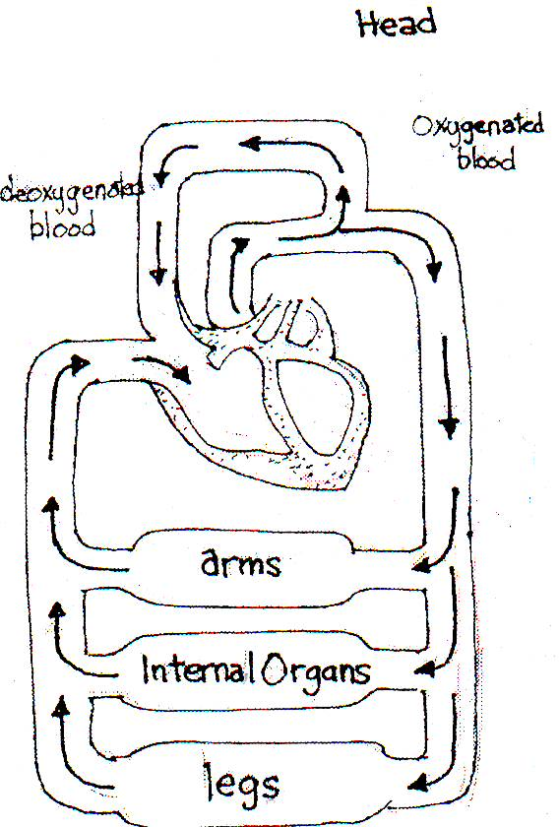

2. Trace the path of blood as shown by the arrows. Write the correct words in each blank.

Blood from the left atrium __________ ventricle, through the aorta

to different _________ atrium

You have just learned about the flow of the blood in a systemic circuit. The systemic circuit carries blood from the heart and to rest of the body.

Read and learn more.

- The blood moves in two major blood circuits: the pulmonary circuit and the systemic circuit.
- The circulation of the blood can be summarized as follows:

- Blood returning from the body travels through a blood vein connected to the heart and enters the right atrium.
- After the right atrium contracts, it pushes the blood past a one-way valve to the right ventricle.

- The ventricle contract and push the blood into lungs passing through pulmonary artery.
- The blood picks up oxygen in the lungs the blood gets oxygen and leaves carbon dioxide.
- Blood from the lungs travel through a pulmonary vein back to the heart.
- Blood enters the left atrium.
- After the left atrium fills, it pushes the blood past a one-way valve.
- The blood fills the left ventricle.
- The ventricles contract and push the blood out heart through the largest artery, the aorta.
(10)Blood rich in oxygen is distributed to all parts of the body.

- The heart seems to act like two pumps.
- The right side of the heart, blood that contains carbon dioxide is pumped to the lungs (pulmonary circuit).
- The left side of the heart, blood that is rich in oxygen, as a result of having passed through the lungs, is pumped to all parts of the body.



Apply It

- What will happen if the blood in your body cannot circulate or move around?

- What makes the blood flow to the different part of the body?



Test Yourself

*

- Complete the flow of blood by filling up the blank with the correct answer.

When the heart expands, blood with more oxygen and nutrients from the lungs flows to the 1. __________ and moves down to the 2. _____________. From the left ventricle, blood moves to the different parts of the 3. _______. From the body, blood with more carbon dioxide flows back to the 4.__________. From the right atrium, it moves down to the 5. _________, to release waste products.

- Complete the phrases below:

The pulmonary circuit carries blood between the________ and the ________.

The _______________ carries blood between the heart and the _________________________.

Key to Correction

Try to Recall

1. Labels of the diagram

- aorta 6. left ventricle
- vein 7. left auricle
- right auricle 8. pulmonary vein
- vein 9. pulmonary artery
5. right ventricle

Activity 1

2. Pulmonary Circuit

Blood from the right atrium, 1. right ventricle pulmonary artery

right and left 2. lungs 3. pulmonary vein 4. left atrium

3. Systemic Circuit

Blood from the left atrium left ventricle, aorta

different parts of the body right atrium

Apply It

- When blood does not circulate, the body cells cannot receive food and oxygen and at the same time cannot clean itself from the different wastes.

- Blood can flow to the different parts of the body because of the “pumping” action of the heart. The contraction of the heart forces blood out into the arteries off to the different parts of the body.

Test Yourself

1. left atrium
2. left ventricle
3. body
4. right atrium
- right ventricle

